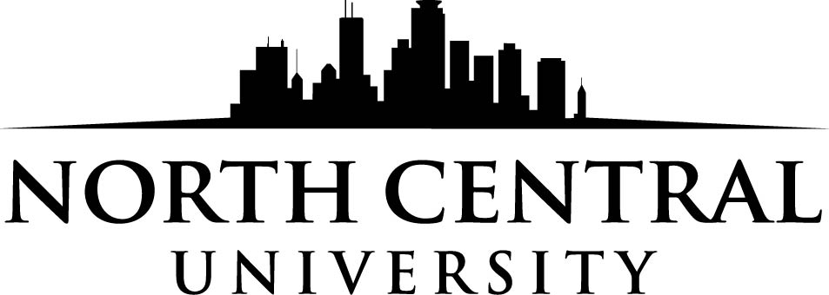

DYD/Outstanding Student Leadership
Scholarship Application
Fall 2022

Scholarship Application Instructions
Eligibility Requirements
- Applicant must be an active member of a local Assemblies of God church or youth ministry.
- Applicant must be enrolling as a first-time student at North Central University for the Fall 2022 semester.
- Applicant must meet North Central University’s standard admissions requirements and agree to our life standard statement. Standard academic requirements include but are not limited to: cumulative high school GPA of 2.2 and an ACT score of 18 or above (or an SAT total score of 850 or above).

Application Instructions
- Applicants must complete the enclosed application form.
- Applicants must provide a one-page essay that answers the following:
  - What is your current involvement with church and/or school?
  - Why do you want to attend North Central University?
  - Why should you be considered for this scholarship?
- Applicants must submit a recommendation letter from their youth leader/pastor that answers the following questions:
  - What is the applicant’s involvement in your church and youth ministry?
  - Why is the applicant deserving of the scholarship?
Award Process
- Students will send their applications, recommendation letter, and essays to their district offices by February 1, 2022.
- The DYD will award up to two students a one-time $1,000 scholarship for North Central University.
- North Central will notify the students selected for the scholarship that they have received the award.

Scholarship applications, personal essays, and leader/pastor recommendation letters must be returned to the district office by February 1, 2022.

DYD/Outstanding Leader Scholarship Application
Student Information
Student name:
Mailing address:
City:__________________________________________ State:______ Zip:
Email address:
Date of high school graduation:_____________ Cell phone:

Church Information
Full name of home church:
Street address:
City:______________________________________ State: _________ Zip:
Church phone:
Name of pastor or youth pastor:

Please attach the one-page essay and recommendation letter to this form.

Applicant’s signature______________________________________ Date:

