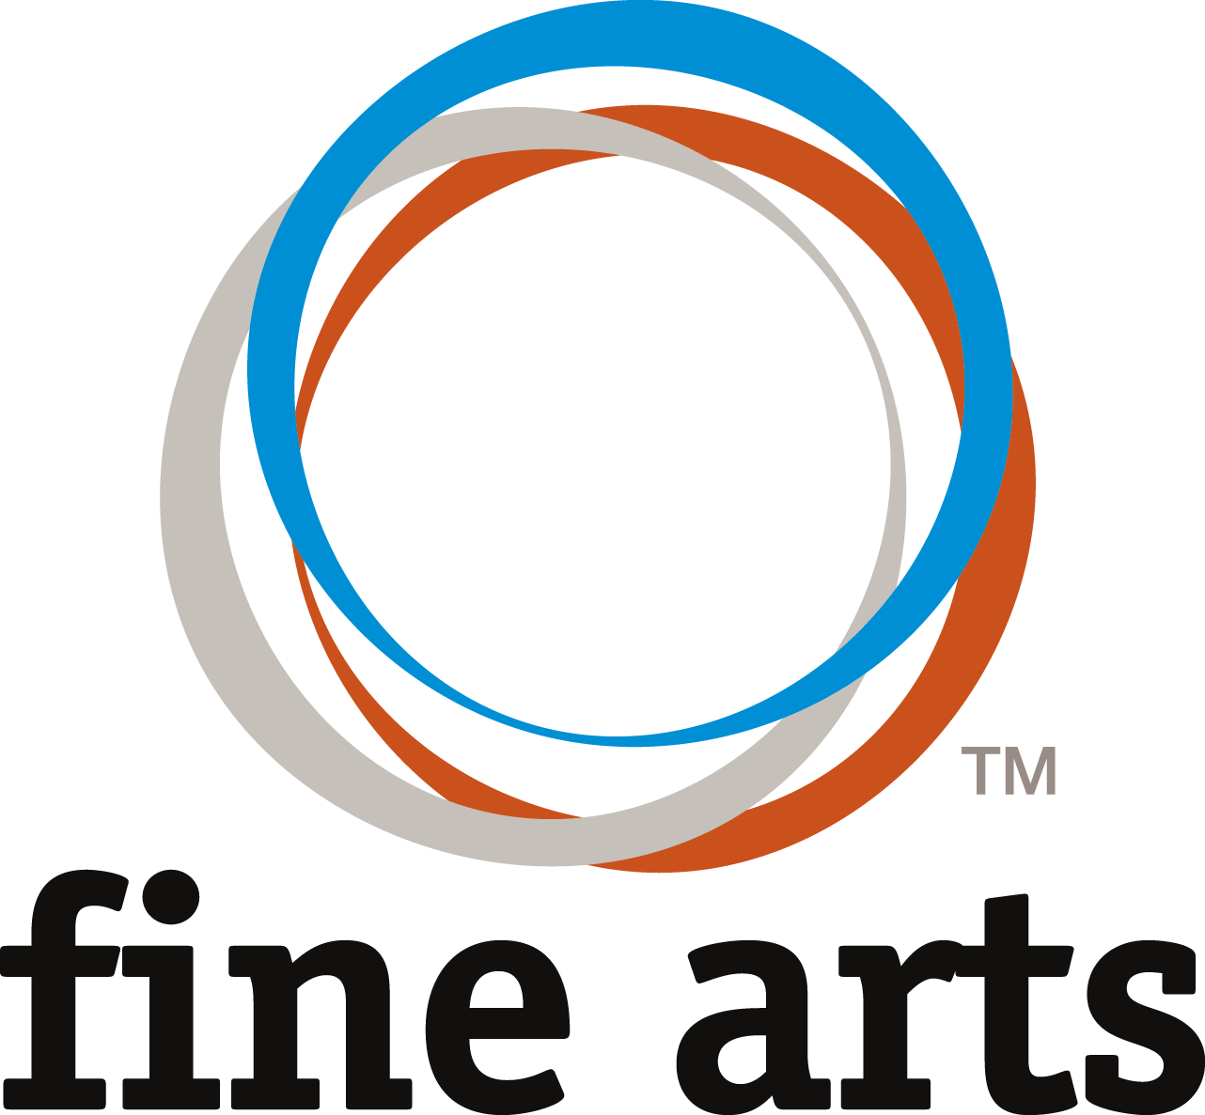
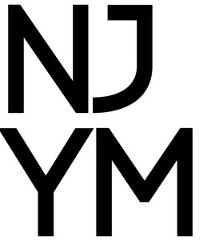
NJ District Fine Arts Digital Submission Information + Guidelines
All writing entries, promo video entries, short film entries, and art entries should be submitted no later than March 31 @ 11:59pm.
All submissions will be evaluated prior to the festival.
A list of entries advancing to Nationals will be posted on the NJYM website at the conclusion of the IN PERSON festival on April 22rd. Certificates and Score Sheets will be sent to the participant’s youth leader by April 30th.

Graphic Design, T-Shirt Design, Photography Mobile/Digital/Film:
Please submit these categories as a high-resolution jpeg or PDF

Visual Art(2D, Painting and Drawing/2D, Alternative Media/3D):
- Submit a 360 degree video showing all sides/angles of your entry
- Start the video showing the front of your entry closer to the level your entry is sitting at, and pause for 5 seconds. Slowly walk around your entire entry at the same level
- When you get back to the front of your entry, continue recording and slowly elevate your recording device and walk around your entry again, to show the elevated view to evaluators.
- When you reach the front of your entry for the second time, continue recording, pause for 5 seconds, and end the recording.
- Record the presentation in landscape layout (phone flipped on side) All videos must be filmed in a well-lit, public place (living room, kitchen, backyard, etc.), not the students’ bedroom.
Good practices for submitting a visual art entry:
Only use a cell phone (no edits, or spliced recordings.) The video must be done all in one take.

All Writing Entries except for Children’s Literature:
Please submit these categories as .pdf files.

Children’s Literature:
Please submit your book as a collection of high-jpeg or png files noting page numbers, or as a PDF.

Directions for Submission:
Writing Submissions [excluding Children’s Literature] must be sent as a .pdf attachment. Children’s Literature entries should be sent as high-jpeg of png files noting page numbers or as a .pdf.
Graphic Design, t-Shirt Design, and Photography Entries should be submitted as a high-resolution jpeg, png, or .pdf file with a .pdf attachment of the types credit line.
All Visual Art, Short Film or Promo Video entries must be sent via accessible Google Drive or Dropbox Link with a .pdf attachment of
the typed credit line/information.
ANY DROPBOX OR GOOGLE FILE MUST BE MADE SHAREABLE
Entries can be submitted by students or Fine Arts Coordinators.
***THESE GUIDELINES AND SUBMISSION DETAILS ARE SOLELY FOR THE NEW JERSEY DISTRICT FINE ARTS FESTIVAL***

